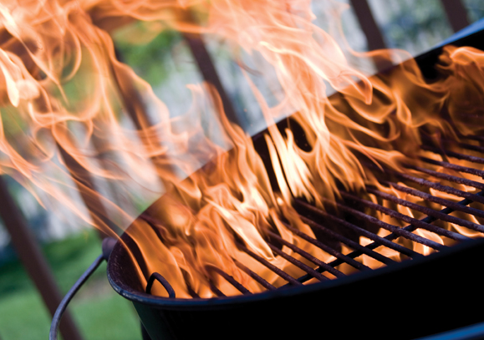
UXBRIDGE SPORTS CLUB CATERING TEL: 01895 237571 admin@uxbridgecricketclub.co.uk
Bar-b-que Buffet Menu

Marinated Chicken drumsticks
Tandoori chicken or Vegetable skewers
Beef burgers
Cumberland sausages
Veggie burgers or sausages

Minted Lamb cutlets (£4 per person supplement)

Burger, sausage buns & relishes are included

Salads
New baby potatoes tossed in minted butter
Potato salad
Coleslaw
Tomato, Mozzarella & mixed leaf salad

Desserts
Fresh Fruit Platter
Selection of mini cakes
Chocolate Gateaux
Fresh Strawberries & Cream.

Suggested Menu Price List
BBQ (4 items) + 3 salads: £23.95 per person
BBQ (4 items) + 3 salads +2 Desserts: £28.95 per person

Any Combination of Items is available.
Please do not hesitate to contact us if you require a quote for a combination not listed

